Final assignment

**1. What is the biggest predictor of a large CO2 output per capita of a country?**

To answer this question I looked for the variable which has the highest correlation coefficient with the CO2 output per capita. To find this variable I used databases from the website [www.ourworldindata.org](http://www.ourworldindata.org/): the CO2-database (see appendix 1.1), the daily caloric supply database (see appendix 1.2), the motorvehicle ownership database (see appendix 1.3) and the GDP share of industry database (see appendix 1.4).

The first variable I looked into is GDP. This might be a good predictor, because if a person has more money, he/she probably spends more on things that cost CO2-emission, for example flights, cars, heating etc.

The second variable is diet. It is known that eating meat generally leads to a lot of CO2-emission. If people consume a lot of animal proteins, it might lead to a high CO2-emission.

The third variable is the number of motor vehicles per 1000 people. More cars, more CO2-emission.

This makes sense, but is it a good predictor of the total CO2-emission?

The fourth variable is the energy source. The use of coal, gas and oil leads to CO2-emission. Let’s find out if they are a good predictor of the total CO2-emission and which of the three is the best.

The fifth variable is the share of industry in GDP. Industry leads to a lot of CO2-emission. So if a country relatively has a lot of industry, it will probably have a high CO2-emission per capita.

To calculate the correlation between the variables and the CO2-emission, I used the Pearson correlation coefficient and the results are in tabel 1:

**Tabel 1: Variables and their Pearson correlation coefficient with the CO2-emission per capita per country**

|  |  |  |
| --- | --- | --- |
| **Variable** |  | **Pearson correlation** |
| GDP per capita |  | 0.6706 |
| GDP per capita since 2010 |  | 0.8012 |
| Diets: | Calories from animal protein (FAO (2017)) | 0.5587 |
|  | Calories from plant protein (FAO (2017)) | 0.0580 |
|  | Calories from fat (FAO (2017)) | 0.5219 |
|  | Calories from carbohydrates (FAO (2017)) | 0.2276 |
| motor vehicles per 1000 people (2014) |  | 0.6200 |
| Energy sources | Coal | 0.7028 |
| (from 2010) | Gas | 0.8237 |
|  | Oil | 0.6946 |
| Share of industry in gdp |  | 0.0989 |

The data in the CO2-database run from 1785 till 2021. The old data are not complete and also not very relevant for the present. Therefore I used the data from 2010. The biggest predictor of a large CO2 output per capita of a country is the amount of consumed gas per capita, followed by the GDP per capita.

The biggest surprise in the results is that the share of industry in GDP is a really bad predictor of the CO2-emission. It has the lowest score.

**2. Which countries are making the biggest strides in decreasing CO2 output?**

To answer this question I used the CO2-database (see appendix 1.1) from the

website[**www.ourworldindata.org**](http://www.ourworldindata.org/)**.** I looked at the data from 1990 and 2020, because before 1990 the Soviet Union still existed and those data are difficult to compare with the data from after 1990. To compare the data from 1990 and 2020 I had to skip the data from Kosovo and Wallis and Futuna, because they didn’t exist in 1990 as an independent country.

First I will show the top 10 of countries with the biggest decrease in CO2 output in absolute numbers:

**Tabel 2. Absolute decrease of CO2 per country**

|  |  |  |  |  |
| --- | --- | --- | --- | --- |
|  | **country** | **co2_1990** | **co2_2020** | **absolute_decrease_co2** |
| 1 | Russia | 2525.518 | 1577.136 | -948.382 |
| 2 | Ukraine | 705.83 | 213.909 | -491.921 |
| 3 | Germany | 1052.477 | 644.31 | -408.167 |
| 4 | United States | 5113.455 | 4712.771 | -400.684 |
| 5 | United Kingdom | 600.344 | 329.579 | -270.765 |
| 6 | Italy | 439.55 | 303.815 | -135.735 |
| 7 | Japan | 1158.007 | 1030.775 | -127.232 |
| 8 | France | 392.998 | 276.634 | -116.364 |
| 9 | Romania | 170.88 | 71.475 | -99.405 |
| 10 | North Korea | 122.4 | 29.311 | -93.089 |

Russia, Ukrain and Germany have the biggest decrease of CO2, but to compare the countries we have to look at the relative decrease of CO2. Here is the top 10 of countries with the biggest relative decrease of CO2:

**Tabel 3. Relative decrease of CO2 per country**

|  |  |  |  |  |
| --- | --- | --- | --- | --- |
|  | **country** | **co2_1990** | **relative_co2_2005_compared_with_1990** | **relative_co2_2020_compared_with_1990** |
| 1 | Moldova | 36.634 | 0.134792815417372 | 0.140497898127423 |
| 2 | North Korea | 122.4 | 0.612091503267974 | 0.239468954248366 |
| 3 | Estonia | 37.65 | 0.455670650730412 | 0.277609561752988 |
| 4 | Ukraine | 705.83 | 0.443616734907839 | 0.303060226966833 |
| 5 | Latvia | 19.661 | 0.39728396317583 | 0.344489090076802 |
| 6 | Lithuania | 35.768 | 0.394682397673898 | 0.385791769179154 |
| 7 | Romania | 170.88 | 0.586721676029963 | 0.418275983146067 |
| 8 | Bulgaria | 76.699 | 0.660451896374138 | 0.488194109440801 |
| 9 | Denmark | 53.573 | 0.961417131764135 | 0.488958990536278 |
| 10 | Slovakia | 61.475 | 0.696104107360716 | 0.499877999186661 |

Moldova, North Korea and Estonia are the countries with the biggest relative decrease of CO2, but to make a really honest comparison between the countries we have to take into account the decrease or increase of the population. So we have to look at the biggest relative decrease per capita. Here is the top 10:

**Tabel 4. Relative decrease of CO2 per country per capita**

|  |  |  |  |  |
| --- | --- | --- | --- | --- |
|  | **country** | **co2_per_capita_1990** | **co2_per_capita_2020** | **decrease_per_capita** |
| 1 | Luxembourg | 30.969 | 13.059 | -17.91 |
| 2 | Estonia | 24.054 | 7.879 | -16.175 |
| 3 | United Arab Emirates | 28.278 | 15.193 | -13.085 |
| 4 | Ukraine | 13.715 | 4.891 | -8.824 |
| 5 | Czechia | 15.879 | 8.215 | -7.664 |
| 6 | Moldova | 8.392 | 1.276 | -7.116 |
| 7 | Singapore | 14.449 | 7.778 | -6.671 |
| 8 | Russia | 17.118 | 10.807 | -6.311 |
| 9 | United States | 20.282 | 14.238 | -6.044 |
| 10 | Slovakia | 11.624 | 5.629 | -5.995 |

Luxembourg, Estonia and the United Arab Emirates are making the biggest strides in decreasing CO2 output.

**3. Which non-fossil fuel energy technology will have the best price in the future?**

To answer this question I used the LCOE-database for non-fossil fuel energy (see appendix 1.5) from the

website[**www.ourworldindata.org**](http://www.ourworldindata.org/)**.**Levelized cost of electricity (LCOE) is defined as the price at which the generated electricity should be sold for the system to break even at the end of its lifetime. With the LCOE it is possible to compare the different sources of energy.

If we compare the data of the different sources of energy for the whole world from 2010 till 2021 using linear regression, we get the following result:

**Figure 1. Prices non-fossil energy technologies (LCOE)**

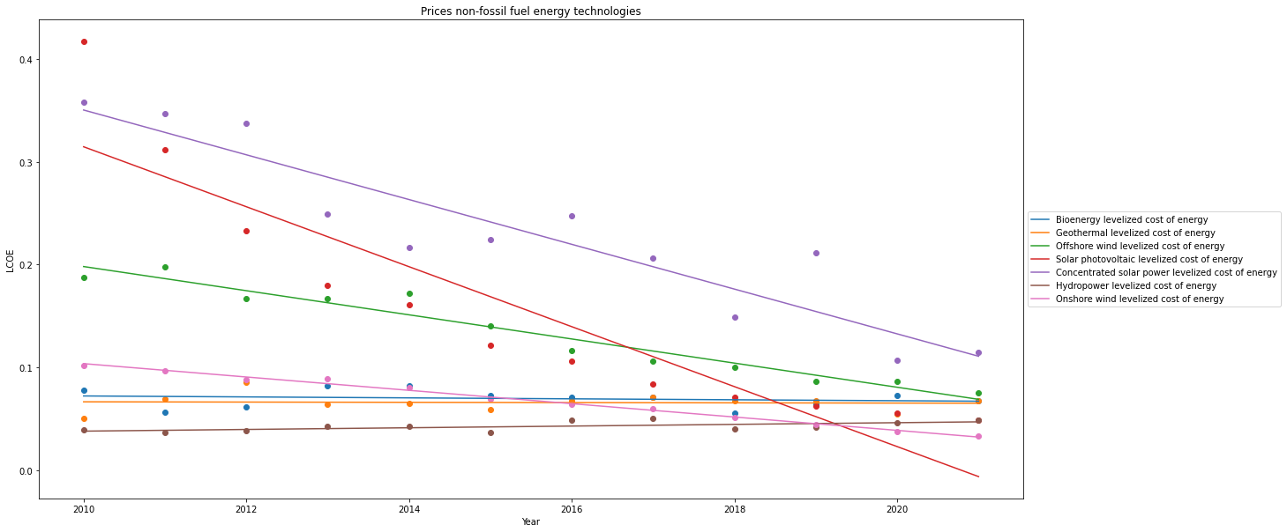

We see that in 2021 the price of onshore wind is the lowest and it is still going down. But what about the red line of solar photovoltaic? The red line is going under the 0, but we also see that if we connect the dots of the red line we get a flattening curve. This means that linear regression is not the best way to predict the price of solar photovoltaic energy. The speed in which the price of solar photovoltaic energy is going down, is decreasing. In the near future the price of onshore wind is the lowest. What is interesting is that bioenergy, geothermal and hydropower are not going down in price but even slightly going up. It is hard to predict the prices in the future, but based on these data it is clearly going to be a close call which non-fossil energy is the cheapest between wind and solar energy.

Appendix 1. Links to the used datasets:

1.1 <https://raw.githubusercontent.com/johanneskar/finalassignment/main/owid-co2-data.csv>

1.2 https://raw.githubusercontent.com/johanneskar/finalassignment/main/daily-caloric-supply-derived-from-carbohydrates-protein-and-fat.csv

1.3 https://raw.githubusercontent.com/johanneskar/finalassignment/main/road-motor-vehicle-ownership-per-1000-people-2014.csv

1.4 https://raw.githubusercontent.com/johanneskar/finalassignment/main/GDP-vs-industry-GDP-at-constant-prices.csv

1.5 https://raw.githubusercontent.com/johanneskar/finalassignment/main/levelized-cost-of-energy.csv

Appendix 2. Used notebook:

[https://colab.research.google.com/drive/1U65HCq-MR6LXqto8Q5p9cgq9qvEXI2GH#scrollTo=vWPj-kNnu4aQ](https://colab.research.google.com/drive/1U65HCq-MR6LXqto8Q5p9cgq9qvEXI2GH" \l "scrollTo=vWPj-kNnu4aQ)